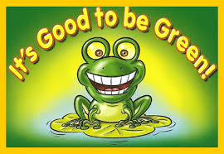
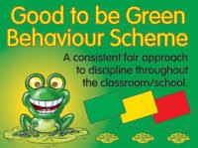
It’s……..GOOD TO BE GREEN
Dear Parents,
You may have heard your child talking about ‘It’s Good to be Green’. This is our new positive behaviour scheme that we have introduced this week. The system works like traffic lights so the objective is to stay on green all the time. Even when a child has received a warning (for low level negative behaviour), they have the opportunity to turn things around and return to full green. Regardless of what happens during one particular day, every child starts on green the next morning. ‘Sammy Stay-Good’, a huge green frog, is the Good to be Green mascot.
For the first five weeks of term, we have been talking to the children about the resources, how the system works and consulting them on what constitutes positive and negative behaviour and the sanctions that the latter should incur. Here is an overview of the scheme. As we go through the year, we will amend and tweak it as the need arises. In the meantime, be sure to check your child’s jumper (P1 & P2) or homework diary (P3-7) every Friday to see if they have managed to stay on green all week.
What does it MEAN….to be GREEN?
We are kind, polite, helpful and aware of others’ feelings.
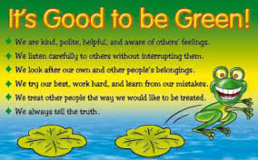
We treat other people the way we would like to be treated.
We always tell the truth.
We try our best, work hard and learn from our mistakes.
We listen carefully to others without interrupting them.
We look after our own and other people’s belongings.
GOOD TO BE GREEN class chart
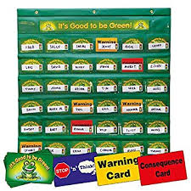

REWARDS
WEEKLY | 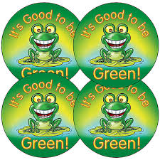  ‘I’ve been Green all week’ sticker (on jumper P1-P2; in Homework diary P3-7)  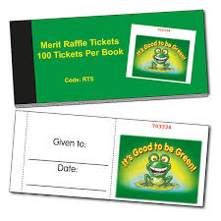  Raffle Ticket with name on it into Rewards Box  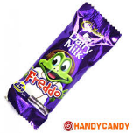  P4-7: Freddos For Fine Behaviour (FFFB) Awards for one pupil in each class
MONTHLY | Celebration Assemblies:  All children who have stayed on Green for 4 weeks - one class at a time - called to front of hall; principal shakes their hands & gives each a small prize e.g. pencil.  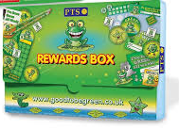  A draw of raffle tickets from each class’ Reward Box for a bigger prize e.g. board game (for one pupil in each class) (therefore, the more weeks a child has stayed on green, the more raffle tickets he/she will have in the box, so the greater the chance of winning the big prize)
TERMLY | ‘Good to be Green’ button badge for those who have stayed on Green all term
ANNUALLY | ‘Good to be Green’ enamel frog badge will replace the two button badges  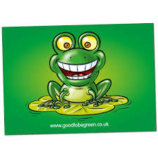  ‘Good to be Green’ postcard sent home (to inform parents of the great news!!)

NEGATIVE BEHAVIOURS & SANCTIONS
LEVEL 1 | - Being off task including wandering / distracting others  - Calling out / speaking over others  - Talking at an inappropriate time; asking inappropriate questions to disrupt  - Not listening / not paying attention  - Pushing / shoving / talking in line  - Talking / running in the corridors  - Not clearing up  - Interfering with others’ property / hiding work or resources  - Not following instructions  - Complaining / muttering disruptively / persistently  - Name calling; making fun of someone | Verbal warning followed by ONE turn of GREEN CARD
LEVEL 2 | - Repeated (>4) level 1 behaviours  - Minor deliberate damage e.g. breaking pencils or other desktop equipment  - Telling lies  - Playing rough  - Encouraging others to misbehave  - Answering back or questioning (disrespectfully) adults’ decisions or requests | YELLOW CARD:  - Recorded in teachers’ ‘Good to be Green’ log book  - Recorded on school system  - Will not receive Friday sticker or Raffle ticket that week  - Yellow sticker in homework diary (on day received) with short explanation by teacher  - 20 minutes off Golden Time on Friday
LEVEL 3 | - Repeated behaviour (for which Yellow card received)  - Using obscene words or gestures  - Refusing to obey instructions / deliberate non-compliance / defiance  - Destroying or deliberately damaging others’ work / property  - Insulting or name-calling using repeated, foul, racist, sectarian or homophobic language  - Threatening violence; deliberately hurting or injuring another pupil  - Bullying | RED CARD:  - Recorded in teachers’ ‘Good to be Green’ log book  - Recorded on school system  - Will not receive Friday sticker or Raffle ticket that week  - Sent to principal (or vice principal) with homework diary; principal puts in Red sticker & records explanation for parents  - Lunchtime detention same day (or next day, if received after lunch)  - No Golden Time on Friday

FURTHER SANCTIONS
If the misbehaviour continues one or both parents will be asked to come to school to discuss the matter with the principal. Further sanctions will include:
- Involvement of parents on a regular basis
- Withdrawal from group activities
- Individual working space within class / working in another classroom
- Regular reports in home / school journal
- Withdrawal of a range of privileges including class trips, extra curricular activities and place on school teams
- Extended Time Out (e.g. lunchtime detentions over a set period; loss of breaktime play; spending playtimes in another playground or on other duties (litter-picking, helping with infant mealtimes))
- Suspension (the procedures as laid out in the EA policy on Suspension and Expulsion will be followed and are available to view)

