Mental Health Awareness Day
Friday 1 March 2019 8.45am-12noon and health checks if desired from 12noon onwards
8.45am-9.00am – Arrival with refreshments. Information stands on support groups such as MensSana, Verve, Al-non Family Groups, Women’s Aid and Menshed in Portadown.
9.00am – 9.05am – Welcome from Mrs Lee, organiser of Mental Health Awareness event.
9.05am – 9.40am Women’s Aid – Helping Hands Programme and what support the Women’s Aid organisation can offer adults.

9.40am-10.00am – Practical session of relaxation techniques and the benefits of yoga from Mairead Morgan.
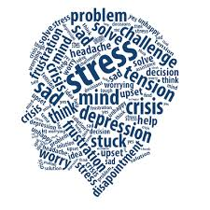
10.00am-10.15am – Effects of drugs – 1 pill can kill – a hard-hitting talk & video by William Burns whose son died at 23 years old.
10.15am-10.30am - Effects of alcohol on friends and family by Al-non Family Groups.
10.30am-10.45am – Break with tea and scones and time to browse information stands.
10.45am-11.30am – Action Mental Health MensSana organisation by Alan Kingsmill - raising awareness of signs and symptoms of mental distress and how to cope positively with stress.
11.30am-11.40am – Men’s Mental Health by Alan McDowell from Menshed in Portadown, including time to ask questions.
11.40am-11.50 am - Take 5 – practical steps to improve mental health and well-being
11.50am-12.00 noon –Alternatives to medication on offer from the Eden Health Shop on dealing with anxiety.
12pm-1pm - A free pop up clinic of health checks if desired from Verve – ‘promoting healthy communities’.
There will be: a free goodie bag for every adult from the PSCP (Policing and Community Safety Partnership)
This event is open to ALL members of the community, young* and old, with or without connections to the school. It is free of charge and will benefit EVERYONE. Please come yourself and bring as many friends and relations with you as possible.
*all attendees must be 16 years of age or older
__ __ __ __ __ __ __ __ __ __ __ __ __ __ __ __ __ __ __ __ __ __ __ __ __ __ __ __ __
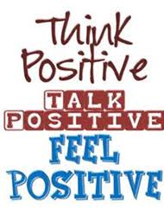
I will be attending the Mental Health Awareness Day on Friday 1 March 2019.
Name: _________________________ (please print) Signed: ______________________________
Please select option below (to enable us to cater for the correct number attending):
I will be coming alone OR there will be ______ people accompanying me.

