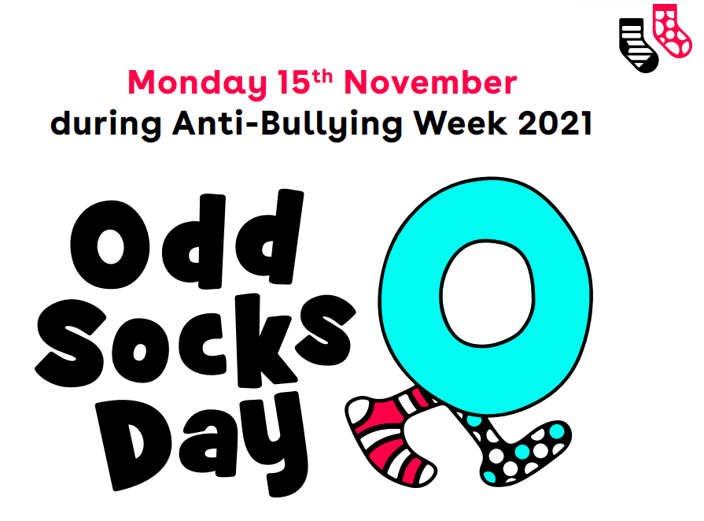

Dear Parents,
We hope all our pupils, parents and staff will come to school on Monday wearing odd socks to mark the start of Anti-Bullying Week 2021!

